SESSION 8 – JOINS: INNER, LEFT, RIGHT

- Create two tables in your SQL database: Users (user_id, username, city) and Orders (order_id, user_id, product, amount). Insert at least 3 users and 5 orders, making sure some users have no orders.
-- Create Users table --
CREATE TABLE Users (
user_id INT PRIMARY KEY,
username VARCHAR(50),
city VARCHAR(50));

-- Create Orders table --
CREATE TABLE Orders (
order_id INT PRIMARY KEY,
user_id INT,
product VARCHAR(50),
amount DECIMAL(10,2),
FOREIGN KEY (user_id) REFERENCES Users(user_id));
-- Insert sample data --
INSERT INTO Users (user_id, username, city) VALUES
(1, 'Khushboo', 'Vadodara'),
(2, 'Amit', 'Ahmedabad'),
(3, 'Riya', 'Surat');
INSERT INTO Orders (order_id, user_id, product, amount) VALUES
(101, 1, 'Pizza', 500),
(102, 1, 'Burger', 250),
(103, 2, 'Pasta', 400),
(104, 2, 'Sandwich', 150),
(105, 2, 'Coffee', 100);
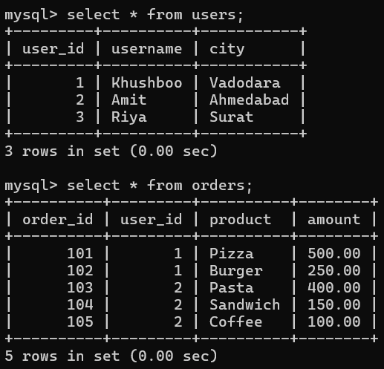
- Write an SQL query using INNER JOIN to list all usernames and their ordered products, showing only users who have placed at least one order.
SELECT u.username, o.product
FROM Users u
INNER JOIN Orders o ON u.user_id = o.user_id;
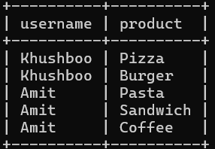
- Write an SQL query using LEFT JOIN to display all usernames along with their ordered products. For users who haven't placed any orders, show NULL for the product.
SELECT u.username, o.product
FROM Users u
LEFT JOIN Orders o ON u.user_id = o.user_id;
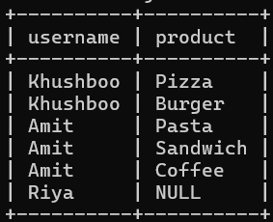

- Write an SQL query using RIGHT JOIN to show all orders and the corresponding username for each order. If an order has a user_id that doesn't exist in the Users table, display NULL for the username.<br><br><em><strong>Hint:</strong> Try deleting one user and keeping their order to test this case.</em>
SELECT o.product, u.username
FROM Users u
RIGHT JOIN Orders o
ON u.user_id = o.user_id;
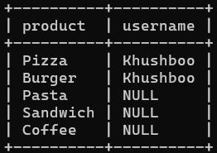

- Suppose you want to analyze food delivery data like Zomato. Create a CustomerSegments table (segment_id, segment_name), and link it to Users with a foreign key. Write an SQL query to show each username, their segment name, and total order amount (use JOINs as needed).
SELECT u.username, cs.segment_name, SUM(o.amount) AS total_spent
FROM Users u
JOIN CustomerSegments cs ON u.segment_id = cs.segment_id
LEFT JOIN Orders o ON u.user_id = o.user_id
GROUP BY u.username, cs.segment_name;
